Autonomous Specification
Three basic modes of commitment have been described (Table 3.3; Davidson 1991). The first is called autonomous specification. In this case, if a particular blastomere is removed from an embryo early in its development, that isolated blastomere will produce the same cells that it would have made if it were still part of the embryo (Figure 3.7). Moreover, the embryo from which that cell is taken will lack those cells (and only those cells) that would have been produced by the missing blastomere. Autonomous specification gives rise to a pattern of development referred to as mosaic development, since the embryo appears to be constructed like a tile mosaic of independent self-differentiating parts. Invertebrate embryos, especially those of molluscs, annelids, and tunicates, often use autonomous specification to determine the fate of their cells. In these embryos, morphogenetic determinants (certain proteins or messenger RNAs) are placed in different regions of the egg cytoplasm and are apportioned to the different cells as the embryo divides. These morphogenetic determinants specify the cell type.
Autonomous specification was first demonstrated in 1887 by a French medical student, Laurent Chabry. Chabry desired to know the causes of birth defects, and he reasoned that such malformations might be caused by the lack of certain cells. He decided to perform experiments on tunicate embryos, since they have relatively large cells and were abundant in a nearby bay. This was a fortunate choice, because tunicate embryos develop rapidly into larvae with relatively few cells and cell types (Chabry 1887; Fischer 1991). Chabry set out to produce specific malformations by isolating or lancing specific blastomeres of the cleaving tunicate embryo. He discovered that each blastomere was responsible for producing a particular set of larval tissues (Figure 3.8). In the absence of particular blastomeres, the larva lacked just those structures normally formed by those cells. Moreover, he observed that when particular cells were isolated from the rest of the embryo, they formed their characteristic structure apart from the context of the other cells. Thus, each of the tunicate cells appeared to be developing autonomously.†
Recent studies have confirmed that when particular cells of the 8-cell tunicate embryo are removed, the embryo lacks those structures normally produced by the missing cells, and the isolated cells produce these structures away from the embryo. J. R. Whittaker provided dramatic biochemical confirmation of the cytoplasmic segregation of the morphogenetic determinants responsible for this pattern. Whittaker (1973) stained blastomeres for the presence of the enzyme acetylcholinesterase. This enzyme is found only in muscle tissue and is involved in enabling larval muscles to respond to repeated nerve impulses. From the cell lineage studies of Conklin and others (see Chapter 1), it was known that only one pair of blastomeres (the posterior vegetal pair, B4.1) in the 8-cell tunicate embryo is capable of producing tail muscle tissue. (As discussed in Chapter 1, the B4.1 blastomere pair contains the yellow crescent cytoplasm that correlates with muscle determination.) When Whittaker removed these two cells and placed them in isolation, they produced muscle tissue that stained positively for the presence of acetylcholinesterase (Figure 3.9). When he transferred some of the yellow crescent cytoplasm of the B4.1 (muscle-forming) blastomere into the b4.2 (ectoderm-forming) blastomere of an 8-cell tunicate embryo, the ectoderm-forming blastomere generated muscle cells as well as its normal ectodermal progeny (Figure 3.10; Whittaker 1982).

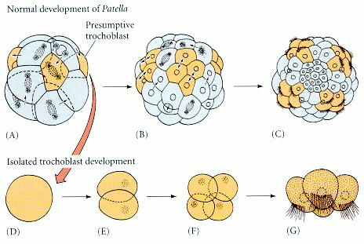
Figure 3.7. Autonomous specification (mosaic development). (A-C) Differentiation of trochoblast (ciliated) cells of the mollusc Patella. (A) 16-cell stage seen from the side; the presumptive trochoblast cells are shaded. (B) 48-cell stage. (C) Ciliated larval stage, seen from the animal pole. (D-G) Differentiation of a Patella trochoblast cell isolated from the 16-cell stage and cultured in vitro. (E, F)Results of the first and second divisions in culture. (G) Ciliated products of (F). Even in isolated culture, the cells divide and become ciliated at the correct time. (After Wilson 1904.)

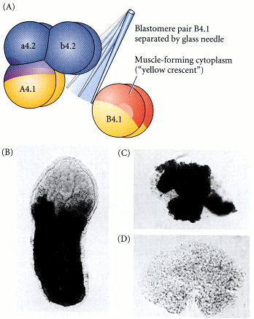
Figure 3.9. Acetylcholinesterase in the progeny of the muscle lineage blastomeres (B4.1) isolated from a tunicate embryo at the 8-cell stage. (A) Diagram of the isolation procedure. (B) Localization of acetylcholinesterase in the tail muscles of an intact tunicate larva. The presence of the enzyme is demonstrated by the dark staining. The same dark staining is seen in the progeny of the B4.1 blastomere pair (C), but not in the remaining 6/8 of the embryo (D) when incubated for the length of time it normally takes to form a larva. (From Whittaker 1977; photographs courtesy of J. R. Whittaker.)

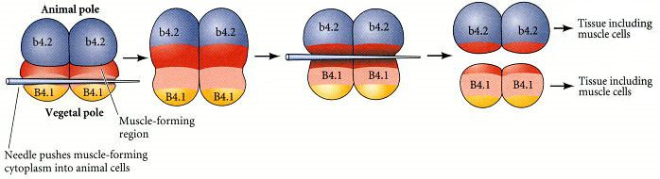
Figure 3.10. Microsurgery on tunicate eggs forces some of the yellow crescent cytoplasm of the muscle-forming B4.1 blastomeres to enter the b4.2 (skin- and nerve-producing) blastomere pair. Pressing the B4.1 blastomeres with a glass needle causes the regression of the cleavage furrow. The furrow will re-form at a more vegetal position where the cells are cut with a needle. The new furrow will thereby separate the cells in such a way that the b4.2 blastomeres receive some of the muscle-forming (“yellow crescent”) B4.1 cytoplasm. These modified b4.2 cells produce muscle cells as well as their normal ectodermal progeny. (After Whittaker 1983.)
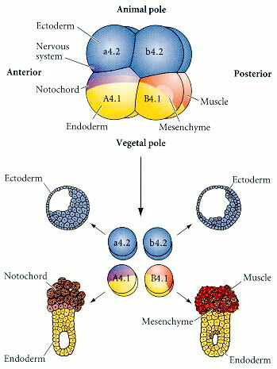
Figure 3.8. Autonomous specification in the early tunicate embryo. When the four blastomere pairs of the 8-cell embryo are dissociated, each forms structures that it would have formed if it had remained in the embryo. (The fate map of the tunicate shows that the left and right sides produce identical cell lineages.) (After Reverberi and Minganti 1946.)

Table 3.3. Modes of cell type specification and their characteristics
I. | Autonomous specification
 | Characteristic of most invertebrates.
 | Specification by differential acquisition of certain cytoplasmic molecules present in the egg.
 | Invariant cleavages produce the same lineages in each embryo of the species. Blasto- mere fates are generally invariant.
 | Cell type specification precedes any large-scale embryonic cell migration.
 | Produces “mosaic” (“determinative”) development: cells cannot change fate if a blasto mere is lost.
II. | Conditional specification
 | Characteristic of all vertebrates and few invertebrates.
 | Specification by interactions between cells. Relative positions are important.
 | Variable cleavages produce no invariant fate assignments to cells.
 | Massive cell rearrangements and migrations precede or accompany specification.
 | Capacity for “regulative” development: allows cells to acquire different functions.
III. | Syncytial specification
 | Characteristic of most insect classes.
 | Specification of body regions by interactions between cytoplasmic regions prior to cellularization of the blastoderm.
 | Variable cleavage produces no rigid cell fates for particular nuclei.
 | After cellularization, conditional specification is most often seen.

